**10/08/2017**

**Steps for installing PMSES on a new machine, using Command Box.**

In C:\projects\cbsites\CF2016

Copy the coldbox directory from an existing coldbox directory, to C:\projects\cbsites\ CF2016. This is at the same level as pms-es will be.

Copy your entire software base (including .git) from a thumb drive to the correct location, e.g. C:\projects\cbsites\CF2016\pms-es.

Use Sublime to make C:\projects\cbsites\ CF2016\go.boxr, containing

**server start cfengine=adobe@2016.0.04+302561 port=50016 name=cf2016 –force**

This defines the CF version, and port for the application.

You can use box interactively, as in

Server start cfengine=adobe@ <TAB>

To see what options are available for the cfengine.

Make  C:\projects\cbsites\CF2016\ server-cf2016.json, containing

{

"app":{

"cfengine":"adobe@2016.0.04+302561"

},

"name":"cf2016",

"web":{

"http":{

"port":"50016"

}

},

"jvm":{

"args":"-Doracle.jdbc.J2EE13Compliant=true"

}

}

This make the characteristics of the driver to Oracle be correct, so the calendar will operate.  This is all using a named commandbox server: CF2016.

At the CommandBox>: prompt, run "recipe go.boxr" in the box environment, to bring up in Chrome a directory listing of C:\projects\cbsites\CF2016.

Be sure the data sources for pmsescb and filestorage are defined. Browse to

127.0.0.1:50016/CFIDE/administration/index.cfm and log in admin/commandbox.

You must define pmsescb and filestorage in there, to point to the Oracle database.

A better way to get the data sources is to use cfConfig in command box. See “CB cfconfig.docx”

Run pms-es with something like 127.0.0.1:50016/pms-es/?fwreinit=true (make a bookmark)

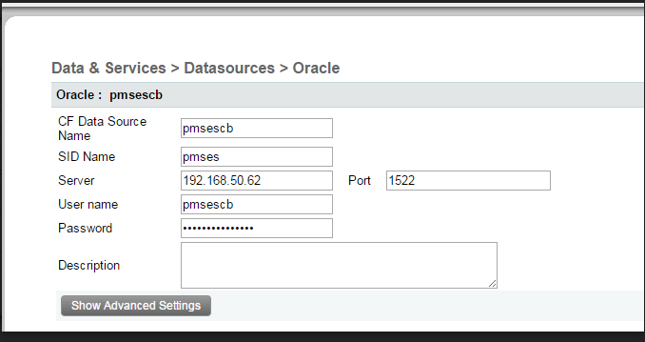

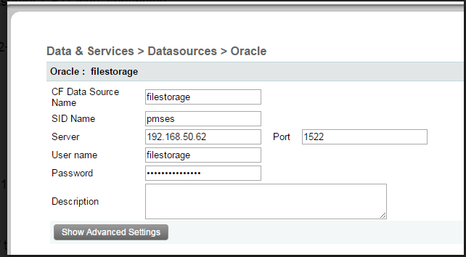

The link to start the application is 127.0.0.1:50016/pms-es/?fwreinit=true